Ujian Tengah Praktikum - Semester Ganjil 2022/2023
Practicum Mid Exam – Odd Semester Year 2022/2023
Matakuliah  Subject |  |  | COMP6799001 – Database Technology |  |  | 
Kelas  Class | : | 09CB |  | Tanggal Mulai  Start Date | : 28 July 2022
Kelas  Class | : |  |  | Waktu Mulai  Start Time | : 13:00
Dosen  Lecturer | : | D3219 - Dr. Tanty Oktavia, S.Kom., MM, CSCA, CDAP |  | Tanggal Selesai  End Date | : 28 July 2022
Dosen  Lecturer | : |  |  | Waktu Selesai  End Time | : 14:10

PERATURAN UJIAN:
Exam Regulations:
- Mahasiswa tidak diperbolehkan berdiskusi dan/atau bekerja sama dengan peserta ujian lainnya
Student is not allowed to discuss and/or work together with other exam participants
- Mahasiswa tidak diperbolehkan menyalin jawaban dari intenet
Student is not allowed to copy answer from the intenet
- Asisten BERHAK memberi nilai 0 (NOL) bagi peserta ujian yang melakukan segala bentuk kecurangan
Assistant is able to give 0 (ZERO) score for exam participant who does any cheating actions
- Kumpulkan jawaban tepat pada waktunya
Submit the answer on time
- Bila Anda tidak membaca peraturan ini, maka Anda dianggap telah membaca dan menyetujuinya
If you have missed to read these regulations, so you are considered to have read and agreed on it

SOFTWARE YANG DIGUNAKAN:
Software will be used:
- XAMPP 7.4.7

FILE YANG DIKUMPULKAN:
File must be collected:
- SQL

PERHATIAN!
Attention!
- Bagi yang mengerjakan tidak sesuai dengan soal, maka akan diberikan nilai NOL (0)
For those who do not work in accordance with the exam case will be marked as ZERO (0)
- Bagi yang mengerjakan tidak sesuai dengan software dan versi yang telah ditetapkan, maka akan tetap dikoreksi dengan software dan versi yang telah ditetapkan
For those who do not work in accordance with the software and specific version will be corrected by the predefined software and version
- Kompres semua jawaban yang akan diunggah. Pastikan format pengumpulan nama file dan ekstensi sesuai dengan format berikut: [NIM]-[NAMA].zip
Compress all file that will be uploaded. Make sure the format for collecting file name and extension according to the following format: [NIM]-[NAME].zip

Tabel Relasional
Relational Table

Starfux

Starfux is a big chain beverage store that spreads across the world. The manager of Starfux in West Jakarta, Felix hired you as the Database Administrator in his store. The owner has several tasks for you to manage some queries as required below. Here is the Entity Relationship Diagram (ERD) of transaction in Starfux.
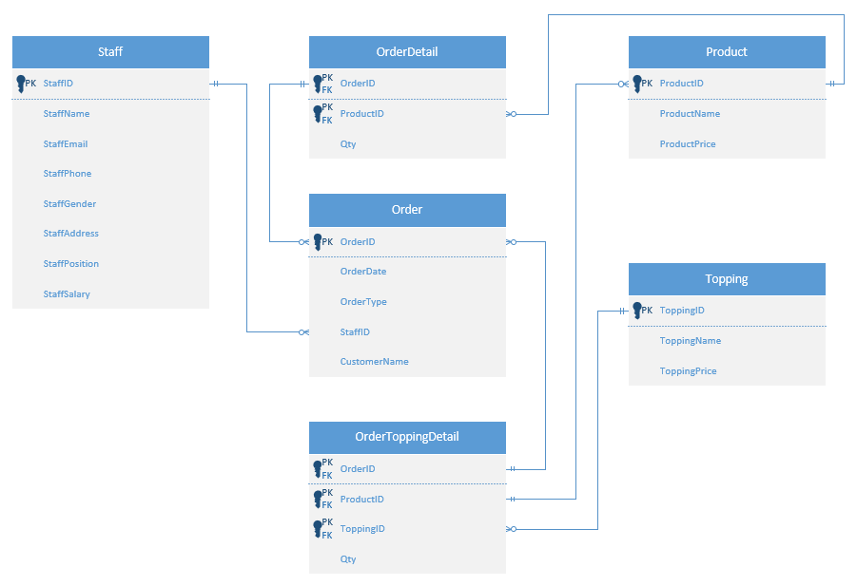

Soal
Case

Note: Import ‘starfux’ database before answering the questions below.

- Create a database named ‘StarfuxPromo’.
(CREATE DATABASE)

- Create a table named ‘WeeklyPromo’ in ‘StarfuxPromo’ database with the following description:
(CREATE TABLE)
Field Name | Data Type | Length | Description
WeeklyPromoID | CHAR | 5 | Primary Key. WeeklyPromoID must be started with ‘WP’ and followed by 3 digits of number.  Example: WP001
WeeklyPromoName | VARCHAR | 255 | Cannot be empty.
WeeklyPromoDay | INT | - | Cannot be empty.
WeeklyPromoDiscount | INT | - | Cannot be empty.

- Create a table named ‘SeasonalPromo’ in ‘StarfuxPromo’ database with the following description:
(CREATE TABLE)
Field Name | Data Type | Length | Description
SeasonalPromoID | CHAR | 5 | Primary Key. SeasonalPromoID must be started with ‘SP’ and followed by 3 digits of number.  Example: SP001.
SeasonalPromoName | VARCHAR | 255 | Cannot be empty.
SeasonalPromoStartDate | DATE | - | Cannot be empty.
SeasonalPromoEndDate | DATE | - | Cannot be empty. SeasonalPromoEndDate must be after SeasonalPromoStartDate.
SeasonalPromoDiscount | INT | - | Cannot be empty.
- Insert these data into WeeklyPromo and SeasonalPromo table:
(INSERT)

WeeklyPromo
PK | WeeklyPromoID | CHAR(5)
 | WeeklyPromoName | VARCHAR(255)
 | WeeklyPromoDay | INT
 | WeeklyPromoDiscount | INT

WeeklyPromoID | WeeklyPromoName | WeeklyPromoDay | WeeklyPromoDiscount
 | TGIF | 5 | 50
WP002 | Work Day | 1 | 2

SeasonalPromo
PK | SeasonalPromoID | CHAR(5)
 | SeasonalPromoName | VARCHAR(255)
 | SeasonalPromoStartDate | DATE
 | SeasonalPromoEndDate | DATE
 | SeasonalPromoDiscount | INT

Seasonal  PromoID | Seasonal  PromoName | SeasonalPromoStartDate | SeasonalPromoEndDate | Seasonal  PromoDiscount
SP001 | Valentine Day | 2021-02-14 | 2021-02-15 | 60
SP002 | Spring Season Celebration | 2021-03-18 | 2021-04-20 | 40
SP003 | Summer Opening | 2021-06-21 | 2021-07-15 | 20
SP004 | Mid Autumn Festival | 2021-09-23 | 2021-10-10 | 30
SP005 | Winter Festival | 2021-12-20 | 2022-01-10 | 35

- From ‘Starfux’ database, display StaffID, StaffName, StaffEmail, StaffPhone (obtained by replacing ‘+62’ into ‘0’ from Staff Phone), StaffGender, and StaffSalary for every staff whose position is “Barista”.
(REPLACE)
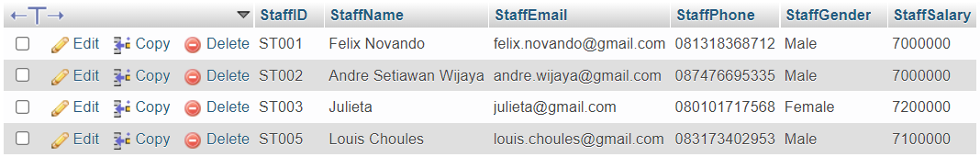

- From ‘Starfux’ StaffID, StaffName, StaffPosition, OrderID, OrderDate, CustomerName, and Orders (obtained from the concatenation of all product names that purchased on the current order and is separated by ‘, ‘) for every order that is not handled by ‘Store Manager’ and not happened on ‘Sunday’.
(REPLACE, GROUP_CONCAT, DAYNAME)
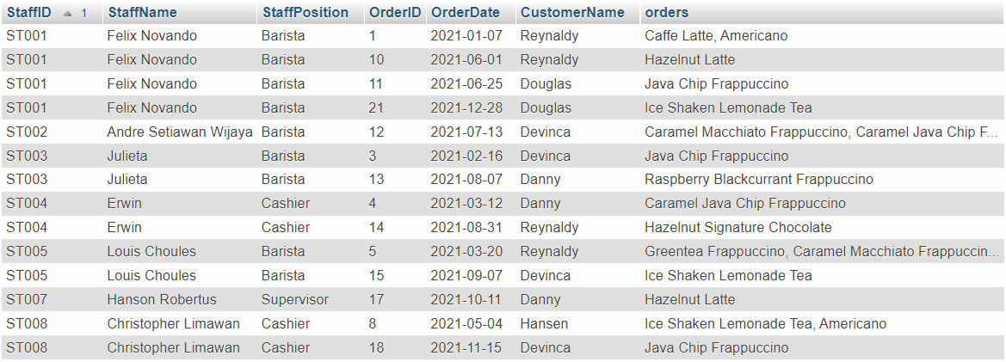

- Display OrderID, OrderDate, CustomerName, StaffName, StaffPosition, SeasonalPromoName, Seasonal Discount for every order which type is ‘Dine In’ and was handled by staff whose position is ‘Barista’.
Note: Seasonal Promo data are obtained from ‘StarfuxPromo’ database, and Orders data are from ‘Starfux’ database that are connected by Date Range (Seasonal Promo) and Weekday Number that started by 1 as Monday (Weekly Promo).
(CONCAT, DATEDIFF)
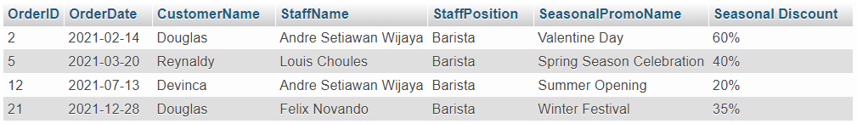

- From ‘Starfux’ database, update Staff data by increasing Staff Salary by 50000 for every staff that handle order which type is ‘GoZeK’ and ‘GrapPood’.
(NULL)

Before update:
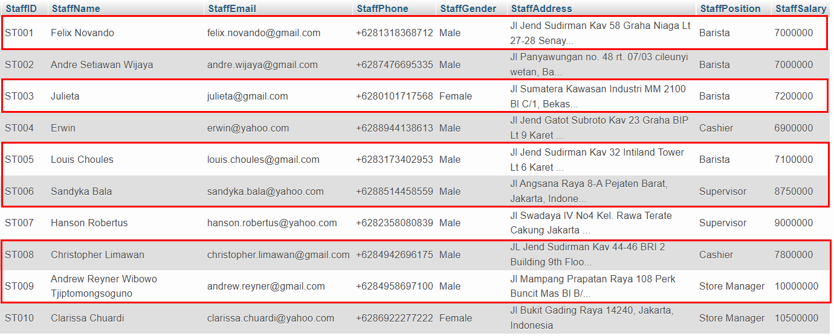

After update:
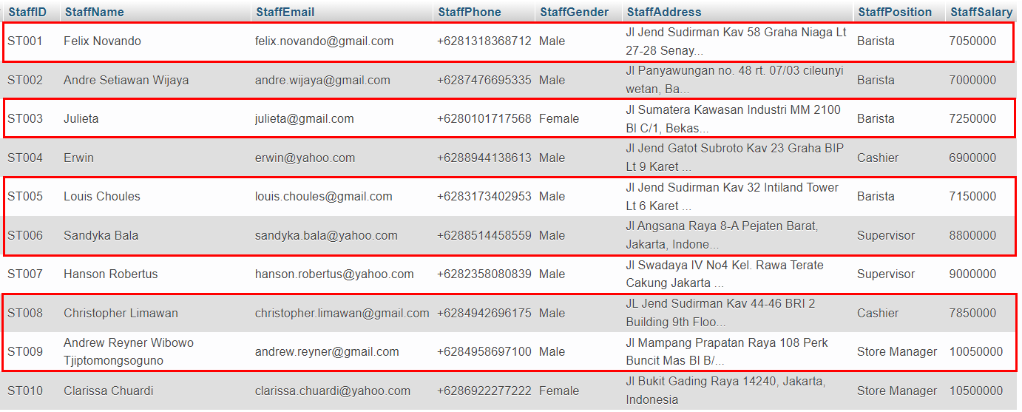

- From ‘Starfux’ database, delete Topping data for every topping that purchased in July.
(DATE_FORMAT)

Before delete:
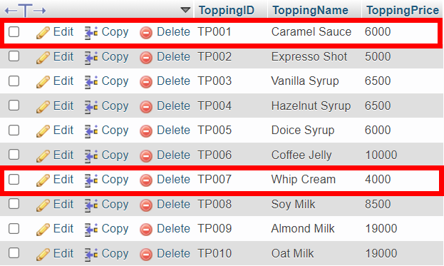

After delete:
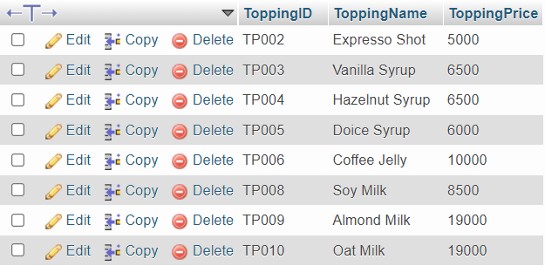

- Delete database named ‘StarfuxPromo’.
(DROP DATABASE)

